KAIte (kīte)
Team: Team BlackBox

Domain Model Description:
The user is the focal point of the application. Since the app was built to help users improve their AI habits through reflection and goal setting. The user may engage in Reflection Conversations with the Reflection Agent, participate in an Error Insertion Mode to improve their accuracy in spotting errors in AI output, change settings to customize their experience, and upload AI usage logs. The agents facilitate the processes hosted by the application, such as redaction of PII from the upload logs for the safety of the user by the Redaction Agent, or the flow of the reflection conversation through the Reflection Agent. The user handles the direction of the conversation through settings (framing choices, goals).

Domain Model Diagram:
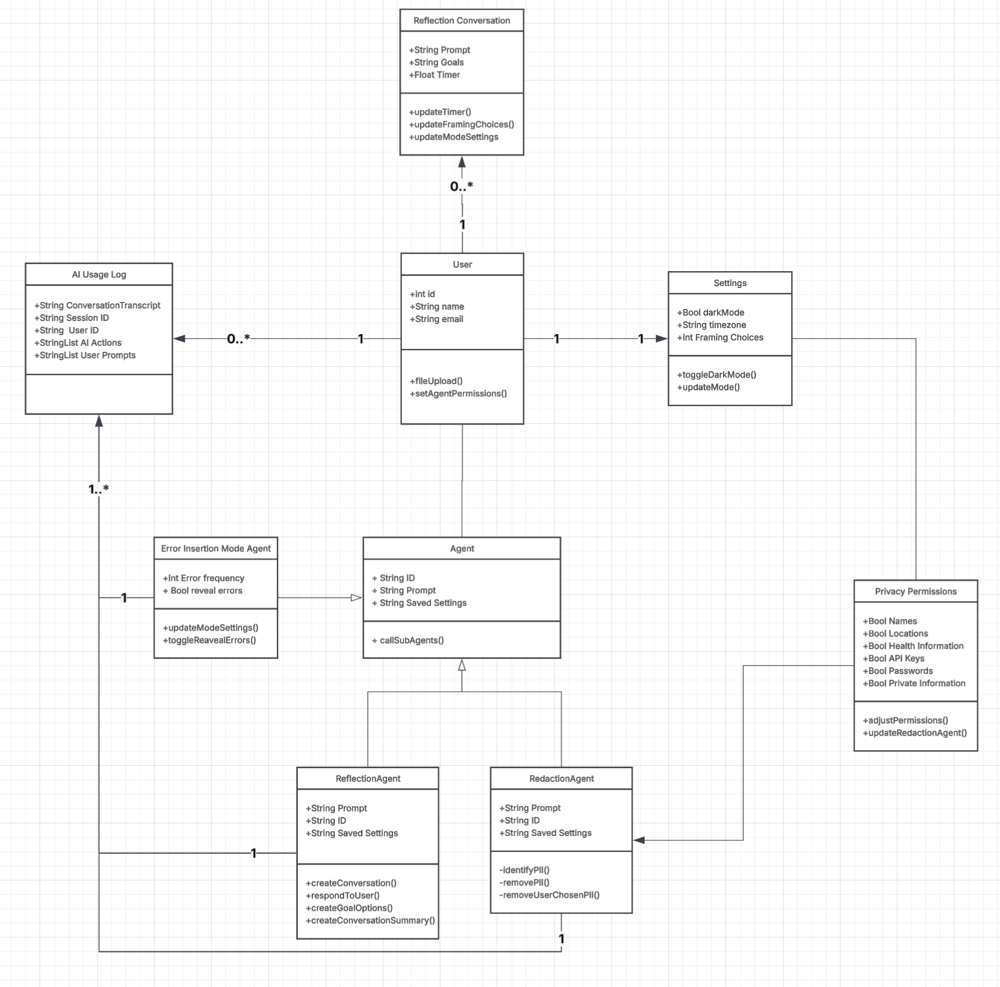

Object List:

Reflection Conversation
- String Prompt
- String Goals
- Float Timer
Methods:
- updateTimer()
- updateFramingChoices()
- updateModeSettings()
User
- int id
- String name
- String email
Methods:
- fileUpload()
- setAgentPermissions()
Settings
- Bool darkMode
- String timezone
- Int Framing Choices
Methods:
- toggleDarkMode()
- updateMode()
AI Usage Log
- String ConversationTranscript
- String Session ID
- String User ID
- StringList AI Actions
- StringList User Prompts
Methods:
- (none)
Error Insertion Mode
- Int Error frequency
- Bool reveal errors
Methods:
- updateModeSettings()
- toggleRevealErrors()
Agent
- String ID
- String Prompt
- String Saved Settings
Methods:
- callSubAgents()
ReflectionAgent
- String Prompt
- String ID
- String Saved Settings
Methods:
- createConversation()
- respondToUser()
- createGoalOptions()
- createConversationSummary()
RedactionAgent
- String Prompt
- String ID
- String Saved Settings
Methods:
- identifyPII()
- removePII()
- removeUserChosenPII()
Privacy Permissions
- Bool Names
- Bool Locations
- Bool Health Information
- Bool API Keys
- Bool Passwords
- Bool Private Information
Methods:
- adjustPermissions()
- updateRedactionAgent()

